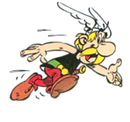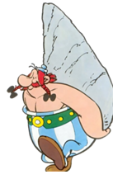
Asterix and the Vikings
- Which expressions are used to describe how the villagers get along with each other?
- What is the name of Vitalstatistix’s nephew?
- Why has he been sent to the village?
- What is the bird’s name?
- What kind of music doesn’t the nephew like?
- What does the Viking leader’s wife want from the next trip?
- Who is not allowed on Viking raids?
- What is a pacifist?
- Who is Abba ?
- When is Doublehélix coming back?
- At the Viking party, who is the toast offered to?
Does this film have hidden messages?

How do the producers portray the following?
Daughter / Father relationships

The treatment of women
Pacifists
Vegetarians
Vikings

