Cooking Show Project
Due: May.27th, 2016
You are going to create and record your own cooking show.
The objective: learn cooking vocabularies and expressions. Improve speaking fluency and practice pausing. Teach your classmates how to make French food.
Requirement
Length: minimum 3 minutes
Your show has
- A written list of ingredients in both French and English
- A written list of tools in both French and English
- Opening and closing of the show
- Explanation of new vocabulary in both French and English
(You teach new vocabulary while demonstrating cooking)
- Step by step demonstration of cooking
- Visual presentation
If you have a partner, both of you have to speak for roughly the same amount of time in the show.
Also, you need to translate your recipe into English and submit it.
Evaluation
Speaking: fluency, pausing, good speed, and clarity of pronunciation
Delivery: eye contact, good voice and body language
Organization of the show: good use of visual presentation, logical flow of sequence of actions, (easy to follow cooking instructions) and smooth flow of the show in general.
Content: Clarity of content (clear instructions), quality of content (details)
Wow factor: uniqueness, creativity, originality and significant effort you put into the project.
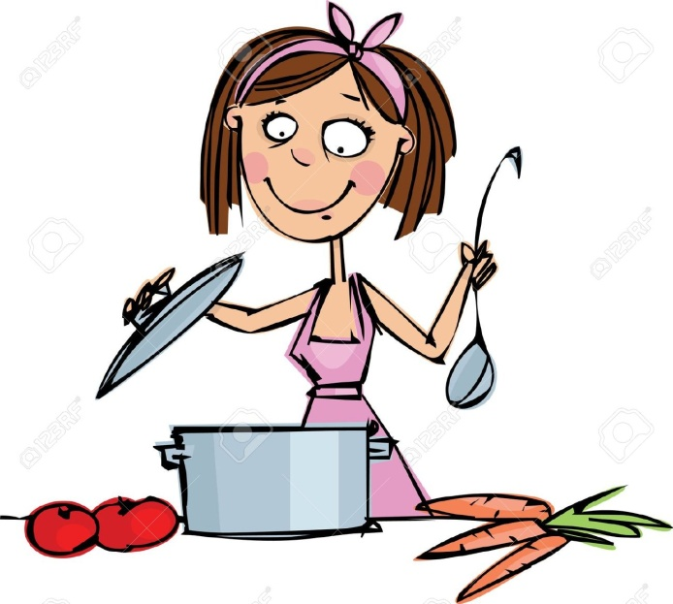
Overall Impression / Quality

Have fun!!

Name :_______________________
Cooking Show Project: Evaluation
Requirement
Length: minimum 3 minutes (3 marks)
Your show has
- A written list of ingredients in both French and English (1 mark)
- A written list of tools in both French and English (1 mark)

- Opening and closing of the show (2 marks)

- Explanation of new vocabulary in both French and English (3 marks)
(You teach new vocabulary while demonstrating cooking)
- Step by step demonstration of cooking (5 marks)

- Visual presentation (3 marks)

If you have a partner, both of you have to speak roughly the same amount of time in the show.
Also, you need to translate your receipt into English and submit.
Evaluation
Speaking: fluency, pausing, good speed, and clarity of pronunciation / 5
Delivery: eye contact, good voice and body language / 5
Organization of the show: good use of visual presentation, logical flow of sequence of actions, (easy to follow cooking instructions) and smooth flow of the show in general. / 5
Content: Clarity of content (clear instructions), quality of content (details) / 5
Wow factor: uniqueness, creativity, originality and significant effort you put into the project. / 5
Overall Impression / Quality / 5

Total mark:

