LESSON: CARTOON HEAD
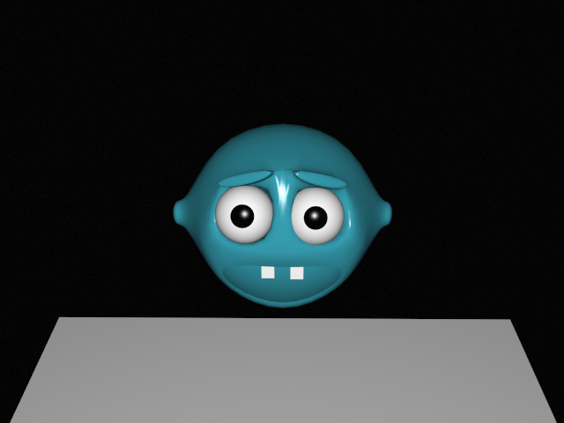

STEPS:

- Insert “Box” – make editable and CatClarkMull Subdivide
- Use polygon mode and select top left polygon – select inner extrude and shrink inside, then extrude and drag back inward (Repeat on right side and lower two poylgons)
- Highlight lower 2 polygons and press delete to blackout
- Delete middle divider of mouth on both sides
- Use point mode and hold shift while selecting upper 2 points of mouth and “weld together” (repeat on lower divider of mouth)
- Use polygon mode and extrude top eyebrows
- Use scapel and create diamond shape on side of head for ears (repeat on other side)
- Use polygon mode to highlight 4 diamond sections and extrude
- Use scapel to create smaller diamond and inner extrude
- Insert “ball” – make editable, scale to 0.25 for X,Y,Z
- Add material default white and drag onto ball
- Use polygon mode to highlight iris and add material default black and drag onto iris
- Rotate and position into eyesockets
- Select Copy eyeball and paste then reposition into other eyesocket
- Subdivide Box
- Add material default choose color and drag onto face
- Add “Box” and scale and position inside mouth for tooth
- Add material default white and drag onto tooth
- Copy and paste tooth and align into mouth for second tooth

