LESSON: CHARACTER
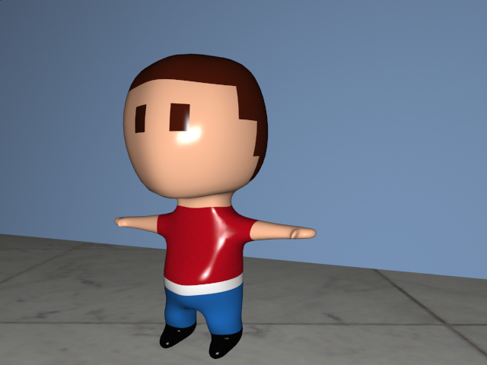

STEPS:

- Insert “Box” – change x, y, z values to 2
- Double click to make editable – add spherify and collapse
- Select half the sphere using select area then delete.
- Click symmetry
- Select bottom 2 polygons and select cover by pressing “C”
- Click on white dot and drag
- Click on red arrow to reconnect
- Click on green box below arrow to flatten
- Click on green arrow to lower neck
- Press Command + Shift + X to select all part of neck
- Click on red box arrow to shrink neck width
- Click on blue box arrow to shrink neck width
- Click on red arrow to reconnect
- Click on blue arrow to move neck further back
- Select dot/line (ie. Edge mode) polygon & highlight middle face line cut by holding shift and clicking lines
- Click rotate tool and use green arrow to lower
- Click on middle face divider then choose ring cut “X” and select along line….do not release button and raise right away.
- Select dot mode then tools – polygon- optimize – ok
- Select rotation tool and select auto mode on object
- Press on dots and drag to give shape to head.
- Select bottom 2 neck polygons and press “C” for cover and pull down an inch using green arrow. Repeat all pull down further to give length to body.
- Widen body by selecting side polygons and pulling out using red arrow.
- Add ring cut down middle vertically of right side and middle of body horizontally.
- In point mode – click on center point at the bottom of body and pull inwards then click on outer point all pull outwards to give shape to leg.
- Select outer 2 bottom polygons and press “C” and pull down for legs. Repeat cover and pull down a little bit more for foot.
- Scale in bottom 2 polygons by clicking colored box and then on white dog and dragging.
- Using loop select move horizontal body ring cut upwards enough to leave room for arms.
- Select bottom 2 belly polygongs and pull out a bit.
- Select polygon for foot and press “C” and pull forward with blue arrow. Scale down with green box.
- Correct foot edges by clicking and dragging out.
- TIP: Flatten foot by selecting all bottom polygons and pull down on green scale box.
- Using point mode - give form to arms before selecting 2 polygons for arms. Press “C” and pull out using red arrow. Scale down using green and blue boxes.
- Press “C” and pull out again. Scale as you go on green and blue axis.
- Repeat step 33
- Add a ring cut horizontally down the leg. Use loop select and pull knee forward.
- TIP: Holding Alt + shift in auto mode allows you to transform and move points, edges, and polygons.
- Select outer 2 hand polygons and press “C” and pull out for hand
- Select thumb polygon and press “C” and pull out.
- Add subdivision.
- Optimize points. Click ok.

