LESSON: CLOCK
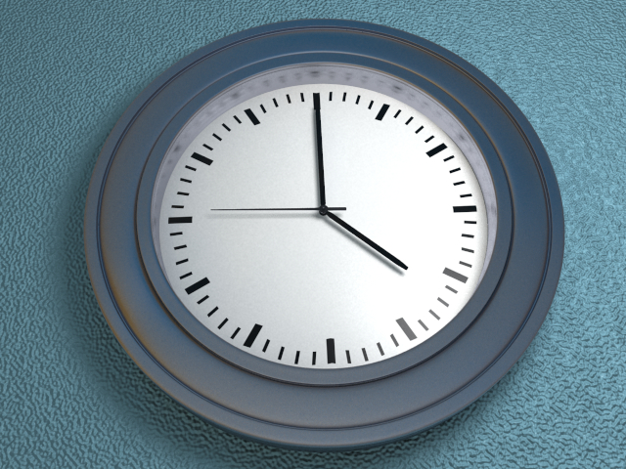

STEPS:

- Insert “tube” – Change height to 0.1 and inner radius to 0.36. Change sections height and ground to 3.
- Make tube editable and go into edge mode.
- Click on selection – loop select or “L” and choose first line in from middle on both top and bottom.
- Click on transform tool and then any colored box and then white dot to scale very close to edge.
- Repeat steps 3-4 for other loop selection.
- Loop select remaining 4 lines on inner and outer by holding shift key. Click on transform tool and use green box and drag to position near edges.
- Add “subdivision”
- Add “Disc” – Scale radius down until just touching inner edges at approximately 0.37 – change corners to 14. Rename to Face.
- Go into camera front view and click on tube in browser and use green arrow to pull up and align on red line. Return to perspective mode.
- Drag Disc from browser under camera. Place lower inside tube using green arrow.
- Add “cylinder” – change height to 0.0075 - change radius to 0.44 and move lower into tube using green arrow. Rename to glass.
- Add material – metal – silver roughbrushed, then drag onto body of clock
- Add material – glass – glass, then drag onto glass in object browser or directly on shape.
- Add default material
- Hide the glass from editor by clicking on “M” and uncheck visible in editor.
- Add “cylinder” – change radius to 0.0025, change sections to 16, change height to 0.08. Push down using green arrow. Rename Pin. Drag metal material onto Pin.
- Add “cylinder” – change radius to 0.01, change height to 0.0025. Change sections longitudinal to 16. Use green arrow to position near top of pin. Rename to Hand.
- Make Hand editable – in polygon mode select 2 of the outer polygons and select cover “C”. Use blue arrow to pull outward. Click red box and drag to make wider. Then select “C” again and drag blue arrow farther out quite long. Press “C” again and drag a little bit further out. Click on red box and drag to make thinner.
- Add default material and change color to almost black. Drag material onto hand.
- In polygon mode use green arrow to drag hand closer to clock face.
- Copy and paste hand. Now on copy hand.1 in polygon mode select two end polygons on tip. Then Click selection – expand selection. Click on transform tool and drag backward using blue arrow. Go back into object mode and drop closer to other hand using green arrow if necessary. Rotate using green semicircle to create obtuse angle.
- Copy and paste hand.1 and move up slightly with green arrow. Rotate using green semicircle.
- Click on edge mode and press Shift + Apple + X to highlight entire hand. Using transform tool drag red box to make hand thinner.
- Press Shift + Apple + D to reduce selection and drag red box to make end more pointy.
- In polygon mode change click on green box and drag to make scale approximately 0.3673
- Drag material silver onto hand.2
- Zoom in to back of hand.2 and in polygon mode select opposite 2 polygons on back of hand from where we extruded polygons. Select “C” for cover and drag out with blue box to give it a tail.
- Position all 3 hands equal distance apart using transform tool and green arrow. Lower pin using green arrow.
- Delete the subdivision on “tube”.
- In polygon mode use ring select to highlight middle tube of clock face. Inner extrude by clicking and dragging to pull inward.
- In edge mode use Loop select and drag 2 inner loops up slightly using green arrow to flatten clock face.
- Go back into polygon mode and reselect middle ring and extrude “E” drag down just slightly by clicking and dragging left.
- Select inner extrude “I” and drag inward slight. Select extrude “E” drag up to about the original position.
- Add “subdivision” to tube.
- Make Glass visible in editor.
- Click on camera in browser and add “plane” – change properties width and depth to 5.
- Add default material and drag onto floor. ie.plane
- Go into node editor. Press Ctrl + click and add node – textures – noise
- Drag a line from noise value to image bumpmap. Change scale in noise tag to 150 in all three boxes. Choose a color for material. Go back to 3D view.
- Add default material load image clock-face and drag onto face.
- Click on camera and add radiosity tag. Add HDRI tag and load panorama image and uncheck background, also change power to 0.5
- Click on glass and add render tag and uncheck visible in radiosity.
- Click on face and add render tag and uncheck filter textures.
- Click on camera and Add “light” – change properties light type to area
- Drag light up and to the right and tilt using red semicircle to direct light towards clock. Change shadow type to raytrace/transparent so that light penetrates the glass, change samples to 8.
- Render.

