LESSON: CUP
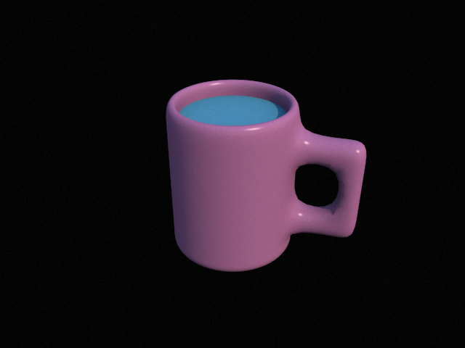

STEPS:

1) Insert “cylinder” – change properties to…..
sections longitudinal: 15
sections height: 6
sections ground: 2
radius: 2
height: 5

2) Make cylinder editable by clicking twice
3) Use polygon tool and select 2 boxes with a space of two between them by holding shift key and select cover then normal move.
4) Drag handles out and select cover and normal move again to drag out further.
5) Use polygon mode and select inside 2 polygons of edge handles top and bottom and press delete
6) Select bridge and click outer edge points
7) Go into edge mode and select ring cut and select on bottom of cup while holding to raise and lower before releasing.
8) Use Selection loop select on top of mug and use rotation tool and select green square to expand while holding shift key.
9) Use Selection Toggle crease after loop is selected
10) Use polygon mode to highlight top of cup and select cover and normal move using green arrow and move inward.
11) Add Subdivision and drag onto cylinder
12) Add material you choose color or texture and drag onto cup
13) Highlight center liquid portion of cup using polygon tool and shift to select triangles then add material default blue and drag onto liquid portion of cup.
14) Add skylight.

