LESSON: EARPHONE JACK
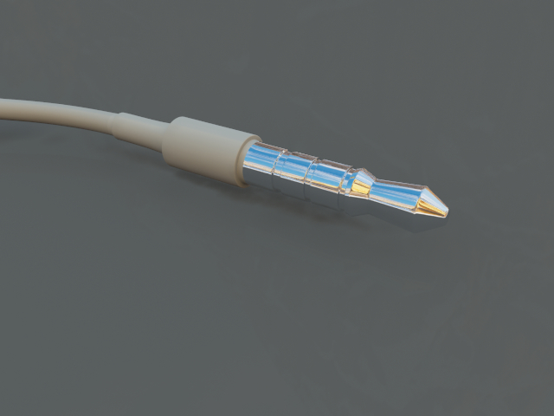

STEPS:

- Insert “Blueprint” – load jack reference into front image.
- Change camera perspective to back.
- Insert “Cylinder” – and go into camera mode – change sections longitudinal to 16 and radius to 0.04 and height to 0.13. Use green arrow to move up a little bit.
- Click cylinder to make editable and select bottom polygons from perspective mode then return to back mode and use green arrow dragging down to lower a little bit.
- Press “C” for cover and click on white dot and drag left. View from perspective mode.
- Press “C” again in back mode and use green arrow to pull down further to end of cord connector.
- Press Apple + Shift + X to increase selection and in back mode use green arrow and drag down to tip. Use green box and drag upward to flatten connection.
- Press Apple + Shift + D to reduce selection.
- Press “C” for cover and click on white dot and drag left a bit then press “C” again and use green arrow to pull down to end of cord.
- In Perspective mode select top polygons and press “C” then click on white dot and drag left to extrude. Press “C” again and use Green arrow to drag upwards.
- Repeat step #7 and #8
- Press “C” and drag upwards, repeat 8 times.
- On the final Cover use red box dragging right to scale inwards.
- Press “C” again and use green arrow to pull up, then use red box dragging left to scale outwards.
- Press “C” again and use green arrow to pull up, then use red box dragging right to scale inward forming tip.
- Press “R” for ring select and holding shift key down select 3 ring divisions.
- Select polygon inner extrude, then click on ring selection. Select polygon normal move and then use white dot to scale inwards.
- Select Ring select and add a ring cut after 3 ring divisions then use blue box and drag to give better shape.
- Highlight loop select upper ring and lower and scale to give shape.
- Select polygon ring cut and add edges all over to make edges more defined when adding subdivision.
- Add 2 material defaults – white and greyish reducing diffuse to black and reflection just a little bit.
- Add silver material
- Collapse Mesh by double clicking cylinder editable icon.
- Delete Blueprint
- Add “Bend” and scale box down. Change Angle to approximately 25 degrees and use arrows to position the wire the way you want it.
- Add “Plane” – click to make editable and stretch to cover cords.
- Copy and paste Jack and position slightly behind the first one.
- Add Radiosity and HDRI and load panoramic background picture but uncheck visible from background.
- Render Image.

