LESSON: MAGNIFYING GLASS
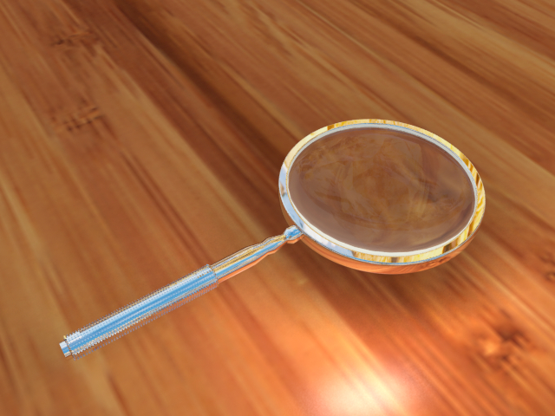

STEPS:

- Insert “Tube” – change inner radius to 0.45 and height to 0.08, change longitudinal sections to 60 and ground sections to 3.
- Insert “Cylinder” – rotate 90 degrees by changing middle rotation number
- Change to side view and use green arrow to position handle at edge of frame – change radius to 0.04 and height to 1.1
- Make handle editable by double clicking – select edge mode and add a few (approx. 4 ring cuts by selecting “X”) and clicking on top portion of handle
- Use Loop select by clicking “L” and click on second ring cut from top then use transform tool and drag to shrink inward by clicking on blue box once then white dot to create form to handle, use green arrow to move closer to lens. (Repeat with lowest ring cut)
- Add a fifth ring cut about half an inch lower than last one and scale outward by selecting loop selection and use white dot to scale outward.
- Rename Shapes handle and frame
- Insert “Ball” – change radius to 0.47 – scale down with green box until lens is convex and use green arrow to position in center of frame. Rename Lens.
- Insert “Cylinder” - Change middle rotation to 90 degrees and use green arrow to place in position near end of handle. Change radius to 0.05 so it is a little bigger than radius of handle and change height to 0.80, use arrows to position.
- Insert “Particle Mesh” – then drag and drop cylinder into mesh properties.
- Insert “Box” – Click green box once then click white circle and drag until small rings appear on handle.
- Select polygon mode and highlight cylinder – change sections height to 55.
- Hold shift key down and click all shapes and then control click and select group. Rename Magnifying Glass. This while allow you to use the rotational tool to move the entire magnifying glass for better viewing.
- Make Frame editable and go to top view then in polygon mode use Ring Select “X” and choose middle row.
- Click on tools – polygon – normal scale and then click and drag to the right to expand selection.
- Add subdivision to the frame to create softer edges.
- Select camera from object browser list and then Add “Plane” – change width and depth to 8.
- Add material “glass” and drag onto lens.

- Add material “silver” and drag onto frame, handle, box from particle mesh, and cylinder.
- Add material default and use texture image and load picture of hardwood flooring, then drag onto plane.
- Select camera from object browser then add radiosity and HDRI.
- Load panorama picture and change rotation to 90 degrees.
- Add “Light” and change properties to light type “area”.
- Position light by dragging green arrow up, then red arrow to the right.
- Change shadow samples to 32.
- Click the “M” in light of object browser then uncheck visible in editor to be able to view scene again.
- Click on Lens in object browser and then select render to uncheck radiosity tag.
- Click on Plane in object browser and then select render to uncheck filter textures.

