LESSON: PLANET EARTH
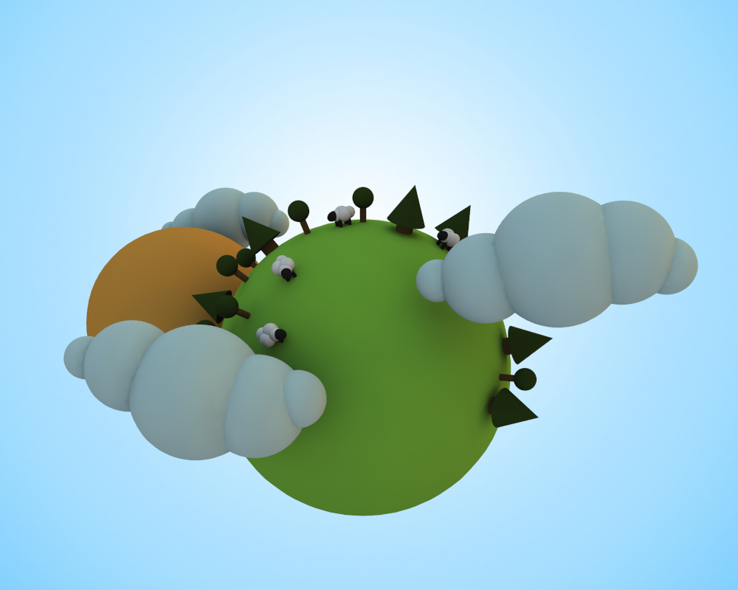

STEPS:

- Insert “ball” and rename earth – change radius to 1.0 and sections longitudinal and parallel to 32.0
- Add default material and change diffuse color to grassy green color. Turn specular off by changing from white color to black. Drag material color onto earth.
- Copy and paste earth and rename to sun. Add default material and change diffuse color to bright orange/yellow for sun. Turn specular off and drag color onto sun. Delete green material from sun in object browser.
- Use red arrow to drag sun behind earth and then blue arrow to drag to the right a bit. Click on any box once and then the white dot to scale to approximately 0.7565
- Go into camera perspective view and rotate to make sure sun is positioned just behind earth and not colliding into it. Return into camera mode.
- Save File.
- Open new file and insert “ball” – change sections parallel to 32
- Add default material and choose a pale blue color for clouds. Turn specular off by changing color from white to black. Drag material color onto ball.
- Copy and paste ball 3 times to end up with 4 balls. Use red arrow to position all 4 side by side like marshmellows.
- Click on second ball from left and click a colored box once and then on white dot to scale up to make larger by dragging right. Click on ball on far right and on a colored square once and white dot to scale down smaller by dragging left. Play around with rotation and scale tools to create the cloud shapes you desire. Copy and paste more ball clouds if you wish.
- Shift and click all balls in object browser to highlight and then press Ctrl + click and select group. Rename group cloud.
- Copy group and paste into first file with planet. Scale cloud down to approximately 0.5 and position on right in front of planet.
- Copy and paste cloud again and position on left behind planet. Scale this cloud mass down to approximately 0.4
- Copy and paste main cloud again and position on left in front of planet. Change middle rotation to -180 degrees.
- Click on camera in object browser and change output resolution width to 1000 and resolution height to 800. Change background color from black to pale blue color similar to clouds. Add radiosity tag. Add HDRI tag and load panoramic picture but uncheck background. Select render to view progress.
- Go back to cloud file and delete all clouds or open new file. Add “cylinder” – change radius to 0.15
- Add “ball” and use green arrow to move directly on top of cylinder.
- Highlight both object from browser and press Ctrl + click to select group. Rename group Tree. Copy and paste tree into main project. Use green arrow to position on top of earth.
- Go into camera front view and scale tree down to approximately 0.14
- Copy and paste green material and change to a darker green and drag onto ball in in browser.
- Copy and paste material again and change to brown color for tree trunk and drag onto cylinder in browser.
- Click on earth in browser and then “M” and uncheck visible in editor. Go into front view.
- Click on tree and pivot mode and drag green arrow until lined up where axis meet. Click back on object mode. Click on earth and recheck visible in editor.
- Copy tree and paste several trees and use colored semicircles to position on earth.
- In new document add “Cone” and add “cylinder” – change radius to 0.22 and height to 0.5
- Highlight both shapes and press Ctrl + click to select group and rename pine.
- Copy and paste Pine into project. In front camera mode use green arrow to drag on top of earth. Click any colored square and then white dot and scale down to approximately 0.25
- Drag and drop correct colors onto tree trunk and top.
- Repeat steps to hide earth and pivot mode to center tree. Repeat with copy and paste trees around earth using rotation tool.
- Open new file – add “ball” turn specular off by changing color to black. Add material default and change to almost white. Drag material onto ball. Copy and paste a 4 new balls and use red arrow to drag to the right so it is halfway out each one. Scale balls as necessary and bunch up balls using rotation tool to create sheep shape. Add a fifth ball at end and add default material black color for the head and drag onto ball. Scale head down using colored boxes so it is not exactly symmetrical.
- Add “cylinder” – change radius to approximately 0.15. Drag black material color onto cylinder.
- Go into camera right view and use arrows to position leg on right side. Copy and paste cylinder and position leg on left side.
- Highlight both legs by using shift click then copy and paste and use red arrow to drag to back of body.
- Shift Click all shapes and then Ctrl + click to select group. Rename sheep. Copy and paste into project.
- Move sheep to top of earth by dragging green arrow. Click on colored box and then white dot to scale down to approximately 0.08
- Repeat steps to hide earth and pivot mode to center sheep. Make earth visible and go back into camera view and copy and paste sheep to position on earth.

