How to Draw a Cartoon Character in 2D Flash:
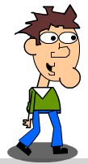
http://adobe-flash.wonderhowto.com/how-to/draw-cartoon-character-flash-287151/

Steps: **make sure you name layers as you work.
1) Create New flash file action script 3.0
2) Insert Oval to create head (make more vertical than horizontal) – change line color to black, fill color to a skin color, change stroke to 3.0
3) Insert new layer above head and rename chin – using oval tool again insert a small circle at right bottom of head
4) Select eraser tool – change options to erase lines – erase part of overlapping circle
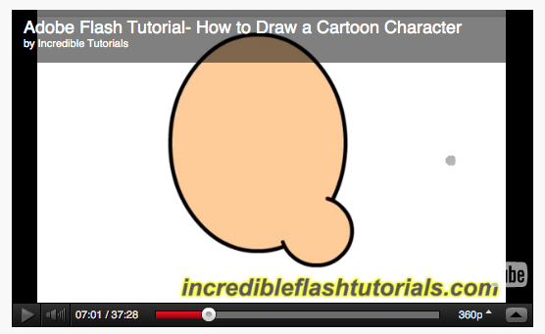
5) Insert new layer above chin and rename chin – using oval tool again create small circle outside the head and then using selection tool double click circle to select and position on the side of the head. Then use eraser tool to delete lines.
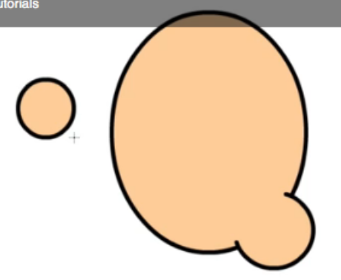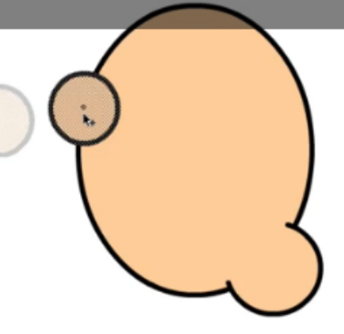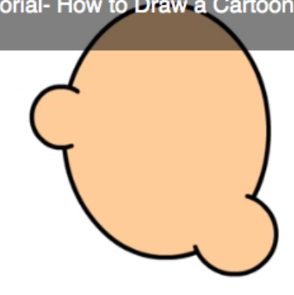
6) Insert new layer above ear and rename eyes – use oval tool and change stroke size to 2.0. Change fill color to white. (Note: we want a smaller stroke size for feature.) Draw oval for eye. Reposition if necessary using selection tool, then copy and paste eye in place and then click and drag next to it.
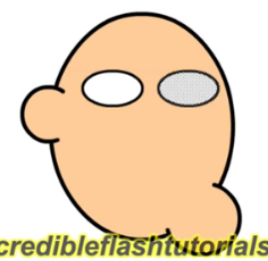
7) Insert new layer above eyes and rename pupils – use oval tool and change stroke color to none and change fill color to black. Holding shift and click and drag to create symmetrical circle. Using selection tool place pupil where you want then copy and paste in other eyeball.
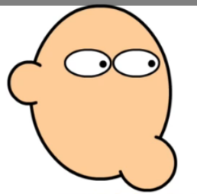
8) Insert new layer above eyes and rename nose (use eyedropper and select eyeball line so that it selects same line types – then select pencil tool to create nose.
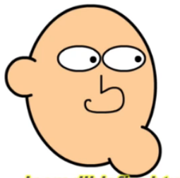
9) Insert new layer above nose and rename mouth – using pencil tool, click hold and drag to create mouth shape. Add a second line down the mouth. Then use paint bucket tool and fill with black color.
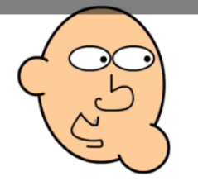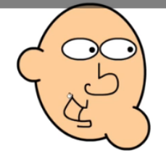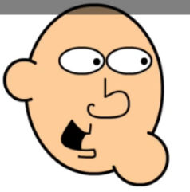
10) Insert new layer above mouth and rename hair - using eyedropper tool select line used to outline face. Use pencil tool to draw hair making sure you reconnect end point with starting point. Use paint bucket tool and choose a fill color.
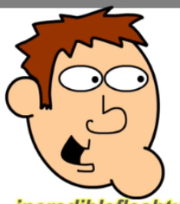
11) Insert new layer above hair and rename eyebrows – use line tool and create a brow. Use paint bucket tool to fill with black color to match outline. Using selection tool double click then copy and paste and position in place. Then flip horizontal to make look symmetrical.
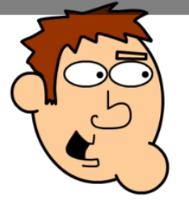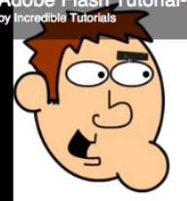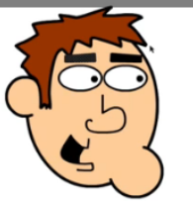
NOW FOR THE BODY……
12) Insert new layer above eyebrows and rename neck – Use rectangle tool and make sure line color and fill are the same as used to create face. Click hold and drag to create neck. Use selection tool and double click rectangle, then select free transform tool and go to bottom right dot so rotation tool appears, then tilt sideways slightly. Then drag neck layer to very bottom of layers so it goes behind the head.
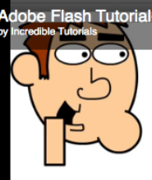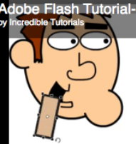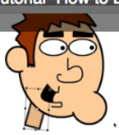
13) Insert new layer above neck and below the head and rename body – Using in line tool draw a triangle at base of the neck. Then use pencil tool to draw upper body. Smooth if necessary by clicking layer and clicking selection tool then clicking smooth a few times as needed. You can also alter by using selection tool and selecting lines and dragging. Then use line tool and draw a line across torso.
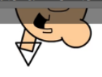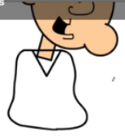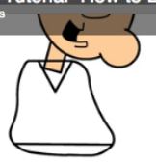
14) Insert new layer above body layer and rename leg - Use line tool and draw a leg. Re-position if necessary using selection tool. Use paint bucket tool and change fill color. Fill in pant leg and lower pant area.
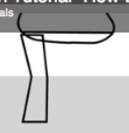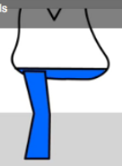
15) Insert new layer above leg and rename shoe – using pencil tool draw shoe, use line tool for base of the shoe. Use paint bucket tool and choose fill color. Drag shoe layer below leg so pans overlap. Select line at top of leg and delete.
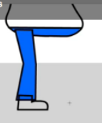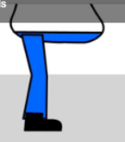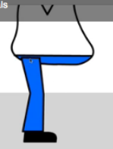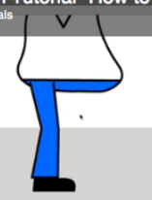
16) Insert new layer above leg and rename leg 2 – copy leg layer and paste into leg 2 layer. Use free transform tool and shrink a bit because that leg is further away. Drag leg 2 layer to very bottom so appear behind the body.
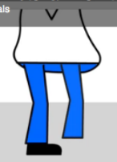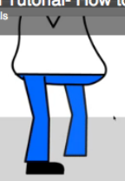
17) Insert new layer above shoe and rename shoe 2 – copy shoe layer and paste into shoe 2 layer. Re-position using selection tool and resize using free transform to shrink a bit. Then drag shoe 2 layer to bottom..
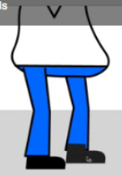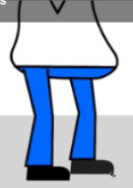
18) Using paint bucket tool choose a fill color for shirt.
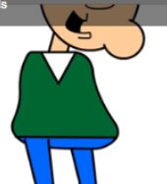
19) Insert new layer and drag to very top and rename arm – use line tool and draw arm. Draw another line near base of shirt. Fill shirt with matching color and bottom of arm with white. Either delete top of sleeve line or make oval.
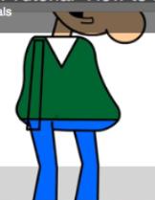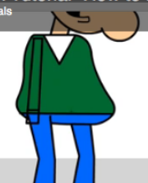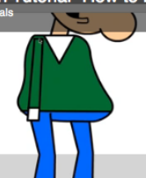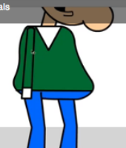
20) Insert new layer above arm and rename hand – use pencil tool to draw hand. Use eyedropper to select match skin color and then paint bucket tool to fill in hand. Drag hand layer below the arm so it looks like its going into the shirt.
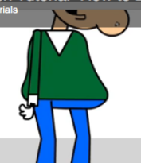 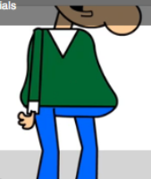May want or add other details like zipper or pocket. 