How to Make a Character Walk in 2D Flash:
http://www.incredibletutorials.com/category/flash-tutorials/page/3/

Steps:
1) Creating Symbols
Using selection tool highlight character. Press control button and click on one dot in timeline to select all frames then copy all frames.
Go to modify and create new graphic symbol – name walking 2. Double click. Create new graphic symbol – name walking 2.

2) Double click symbol to go into symbol walking 1 and paste all frames. Merge foot layer with leg layer by cut and paste into leg layer.
3) Using bone tool – lock all layers except leg layer – click on leg and drag to create 2 bones. Using selection tool, test for movement.
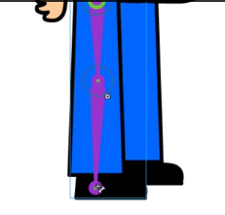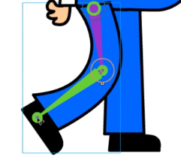
4) On armature layer for leg 1…..Go to frame 10 and insert a pose. Go to frame 20 and insert a pose. On frame 20 insert a pose for all other layers.
5) Return to frame 1 for armature layer and create a pose. Click on frame 10 and create forward leg pose. Copy pose from frame 1 to frame 20.
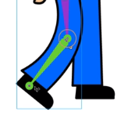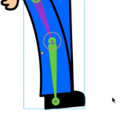
6) Lock all layers except leg 2 layer. Hide layers that are in the way. Using bone tool again create 2 bones. Using selection tool, test for movement. Click eye icon to bring everything back into view.
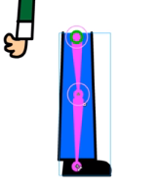
7) On armature layer for leg 2…..Go to frame 10 and insert a pose. Go to frame 20 and insert a pose. On frame 20 insert a pose for all other layers.
8) Return to frame 1 for armature layer leg 2 and create a pose. Click on frame 10 and create forward leg pose. Copy pose from frame 1 to frame 20.
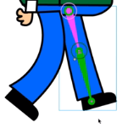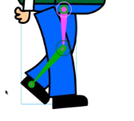
9) Go into walking symbol 1 and insert key frames at 10 and 20. At frame 10 move symbol down a bit so it appears he is bobbing as he is walking. Insert a classic tween.
10) Return to main scene – on frame 1 drag character to left. Then on frame 50 insert keyframe and move character to far right. Create a classic tween.
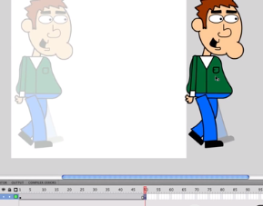
11) Double click symbol twice to return to symbol with layers. Unlock all layers and click arm layer and hand layer by holding shift and then create new graphic symbol
12) Click on white dot and drag to top of shoulder so that I can pivot arm.
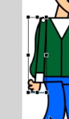
13) Insert keyframes on 10 and 20. Click on frame 10 and position arm forward. Create a classic tween between frames 1 and 10.
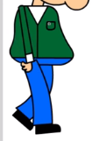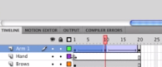
14) We can slow walk down by clicking on dot at frame 20 and extending further.
15) Select armature layer for leg 1 and and convert to frame by frame animation so we end up with individual frames.
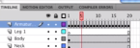
16) Going through each individual frame use selection tool to highlight top of leg line and delete.
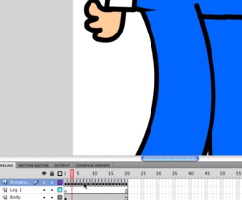
NOTE: If your leg is not completely connected when walking then lock both leg layers and highlight everything else and move down a bit.
17) Go into first symbol – walking 1 – create new layer and drag to bottom. Using oval tool with black fill, draw a shadow beneath feet. Create new symbol from this layer and rename shadow. Go to color effect and change to alpha about 75%.
