Creating a scrolling background in 2D Flash:
http://www.incredibletutorials.com/category/flash-tutorials/page/2/

Steps:
1) Double click fence symbol to go into it – copy and paste fence posts over then transform to make a little different.
2) Copy and paste horizontal posts and transform to make a little different.
3) Extend posts to match up to original posts and delete connecting line.
4) Double click road symbol to go into it – select side and drag to the left to extend using free transform tool.
5) Use eyedropper tool to select road lines and draw new lines on extended road. Using selection tool highlight road lines and change width on a few to give variation.
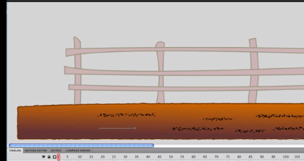
6) Copy and paste rocks over to new road.
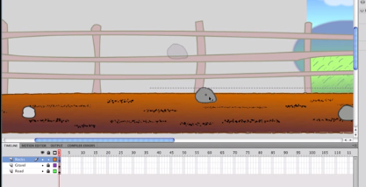
7) Double click on grass symbol to go into it – extend to left. Copy and paste grass layer to fill new area.
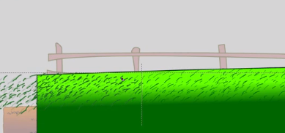
8) Double click hills symbol to go into it – copy and paste hills to the left
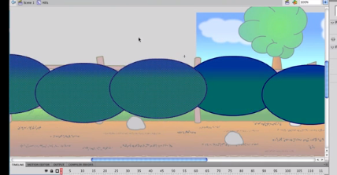
Now we can begin scrolling process……
9) In original scene go to frame 150 and apply a keyframe to all layers.
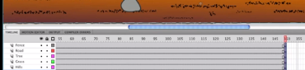
10) At frame 150 click on road layer and drag to the right as far as you want to go.
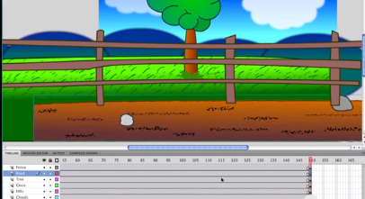
11) Repeat for the fence.
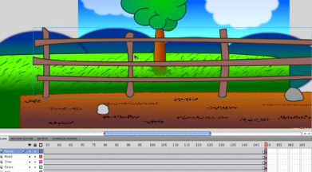
12) Click the tree and holding shift select the grass and drag to the left, but not as much as the tree will not be moving as fast as the road.
13) Repeat for hills but don’t move very much at all.
14) Create a classic tween for the road, tree, fence and grass.
15) Insert new layer and rename character – copy and paste character into scene the flip horizontal. Position and shrink using free transform.
Test movie.

