Unit 3 Review Assignment
Complete all questions in the spaces provided on this sheet.
1. a) Give each of these graphs a title. Either “Position/Time Graph” or “Velocity/Time Graph”
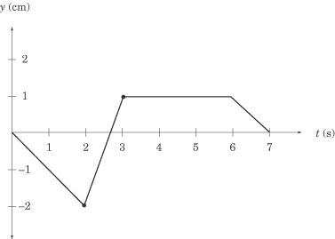
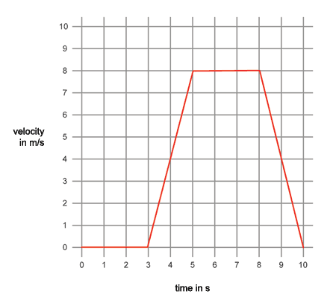
b) What does the slope of each graph tell you about the objects motion?
Position/time graph: _______________________________________________________________________________________________________________________________

Velocity/Time graph:
______________________________________________________________________________________________________________________________________
c) When the slope of each graph is zero, what does that tell you about the objects motion?
Position/Time Graph_________________________________________________________________________________________________________________________________
Velocity/Time Graph_________________________________________________________________________________________________________________________________
d) Calculate the velocity of the object from 2s to 3s on the position/time graph

e) Calculate the acceleration of the object from 3s to 5s on the velocity/time graph.

2. Answer all of the questions below using one of the 6 formulas we used in class.
$v=\frac{Δd}{Δt}$ $Δt=\frac{Δd}{v}$ Δd = (v)(Δt) $a=\frac{Δv}{Δt}$ $Δt= \frac{Δv}{a}$ Δv = (a)(Δt)

a) What is the acceleration of a car whose velocity changed from 50 km/hr to 100km/hr in 15 seconds?

b) How long would it take for a race car to travel 500 km at an average velocity of 125 km/hr?

c) If a speed skater changed velocity from 15 m/s to stopping with an acceleration rate of 5 m/s², how long would this take?

d) What would the change in velocity be if an airplane accelerated at a rate of 9.3 m/s2 for 30 seconds.

e) How far would a car travel if it averaged 80 km/hr (N) for 2.3 hours?

f) What is the velocity of a squirrel who is able to climb a 15 m tall tree in 3 seconds?

